A guide for families new to Thurrock

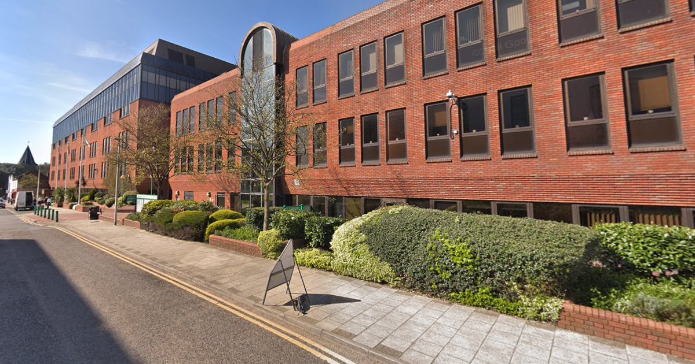

Purpose of the Guide

This guide is for new families relocating to Thurrock. It contains information about your new local area, details about council services, health services, places of worship, community groups for parents, social activities for children, and other groups or networks of support. Details are also given on travel and transport in the borough.

About Thurrock
Thurrock’s unique location at the heart of the Thames Estuary is just a short stone's throw to the east of London, and Essex to the north and west. On our doorstep are plenty of rich opportunities thanks to our lively towns and peaceful villages surrounded by acres of parks, countryside and heritage sites.
Our urban centres are a vibrant mix of established towns and new young communities, with a diverse and growing population of around 160,000 residents. Rents are more affordable than those in neighbouring London boroughs. Our population is diverse, with a mix of nationalities living across our towns and villages.
Thurrock, which is one of the largest growth areas in the UK, has an ambitious regeneration agenda with billions of pounds of planned investment in new jobs, infrastructure and homes. Thurrock Council is the lead authority for the new Thames Freeport, and is playing a key role in the delivery of projects such as South Essex Estuary (SEE) Park and the Technical University through the ASELA partnership.
Even with these regeneration plans, our borough has plenty of green belt areas and those who prefer unspoiled countryside will enjoy our nature reserves along with many other open parks and woodlands.
Thurrock can offer an excellent quality of life.
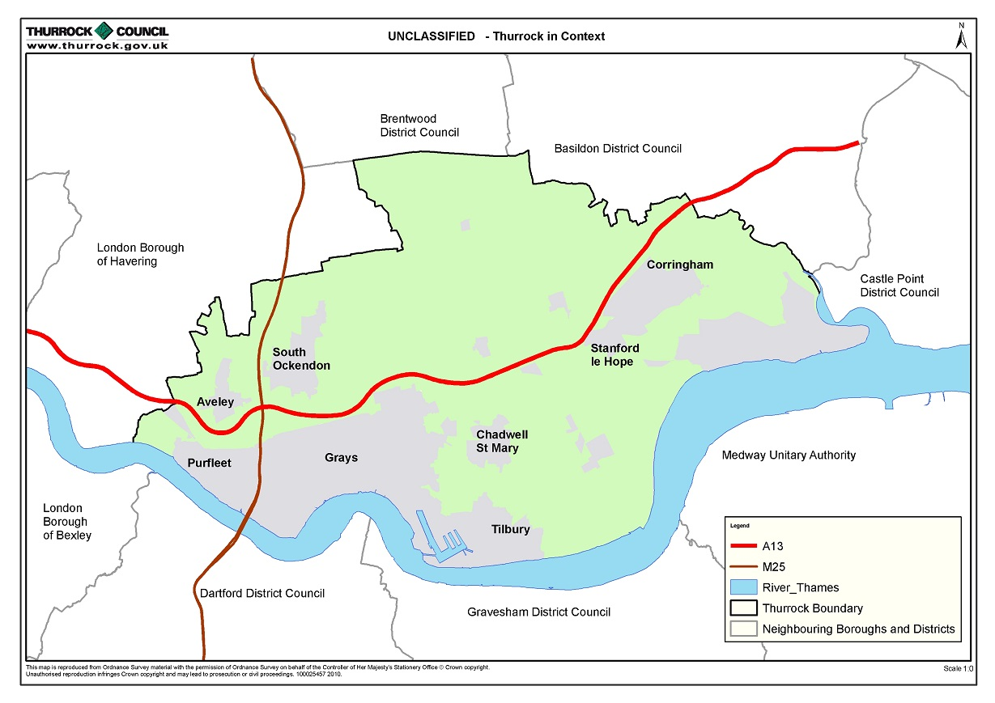
Thurrock Council Services and Website
Thurrock Council’s website will signpost users to helpful information and services. Below are the links to the different services residents may need and can use to gain help and advice.
www.thurrock.gov.uk
Adults Care & Health  Business & Licensing  Children & Families  Community & Living  Council & Democracy  Education & Learning  Environment & Safety | Housing  Jobs & Careers  Leisure & Culture  Money, Tax & Benefits  Planning & Growth  Travel & Transport  Waste & Recycling
  www.thurrock.gov.uk/adult-care-and-health
  www.thurrock.gov.uk/business-and-licensing
  www.thurrock.gov.uk/children-and-families
  www.thurrock.gov.uk/community-and-living
  www.thurrock.gov.uk/council-and-democracy
  www.thurrock.gov.uk/education-and-learning
  www.thurrock.gov.uk/environment-and-safety
  www.thurrock.gov.uk/housing
  www.thurrock.gov.uk/jobs-and-careers
  www.thurrock.gov.uk/leisure-and-culture
  www.thurrock.gov.uk/money-tax-and-benefits
  www.thurrock.gov.uk/planning-and-growth
  www.thurrock.gov.uk/travel-and-transport
  www.thurrock.gov.uk/waste-and-recycling

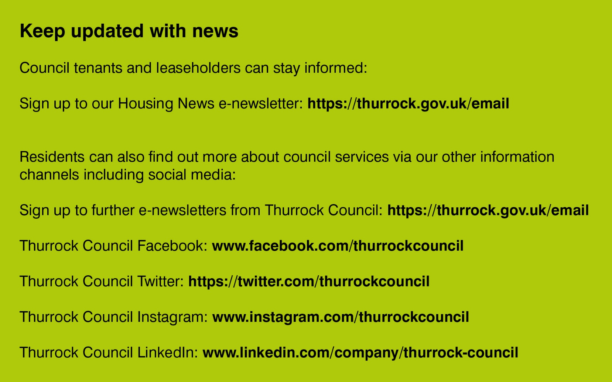

Contents
Section 1 - Housing 5
Section 2 - Education & Schools 5
Section 3 – Family Information Service 6
Section 4 - Children’s centres 6
Section 5 – Employment & Benefits 6
Section 6 - Foodbanks 7
Section 7 – Pre loved household items 7
Section 8 – Essential Living Fund 8
Section 9 – Help with Fuel Bills 8
Section 10 – Sports, Leisure & Positive Activities 8
Section 11 – Waste & Recycling 8
Section 12 – Community Groups 9
Section 13 – Churches / Faith Groups 9
Section 14 - Hospitals and General health 11
Section 15 – Disability and Carer Support 12
Section 16 – What you can expect when renting in the private sector 12
Section 17 – Well Homes Service 14
Section 18 – Transport & Travel 14
Section 19 - Parent Gangs Advice Leaflet 15
Section 20 - Emergency contacts: 18
Section 21 - Victim Support 18
Section 22 - Reporting crime anonymously 18
Section 23 - Hate crime 18
Section 24 – Worried about a Child 19
Section 25 – Other useful contacts 20

Section 1 - Housing
You will not be eligible to register to bid on Thurrock Council housing until you have lived in the borough for the last six years or have a local connection (close family members who have lived in Thurrock continuously for the previous six years). Nor will Thurrock Council have a duty to assist you in finding accommodation unless you fall within this six-year rule. Should you believe you are likely to become homeless, you should contact the council, which placed you in Thurrock in the first instance. Thurrock Council may consider helping you if you can show that you cannot return to your home borough in this instance; our services will likely help you find a more settled private rented property. You will need to make a homelessness application online.

www.thurrock.gov.uk/finding-somewhere-to-live/your-housing-options

www.thurrock.gov.uk/finding-somewhere-to-live/applying-for-council-housing

Contact the Homelessness team: 01375 652 820. Email:housingoptions@thurrock.gov.uk

www.thurrock.gov.uk/homelessness/if-youre-homeless-or-likely-to-become-homeless

Section 2 - Education & Schools
There are many schools and colleges in the borough that cater for all levels of learning abilities. There is also an adult community college.
If you need to apply for a school place outside of the usual times, you will need to make an in-year admission application.
Thurrock Council's School Admissions team will help you find a school with a place; you can contact them on 01375 652 883 or email: school.admissions@thurrock.gov.uk
You can then apply online by using our school admissions applications service. For some schools, you will also have to send a completed form directly to the school itself.

www.thurrock.gov.uk/in-year-admissions/applying-in-year
www.thurrock.gov.uk/primary-schools
www.thurrock.gov.uk/secondary-schools
www.thurrock.gov.uk/special-schools
www.thurrock.gov.uk/colleges
www.thurrock.gov.uk/community-college

Section 3 – Family Information Service

Thurrock’s Young People & Families Directory is an online directory of local services to help children, young people and families.
The information and advice here are for young people up to the age of 25, parents, prospective parents and carers.
Email: fis@thurrock.gov.uk Contact: 01375 652 801

www.askthurrock.org.uk/kb5/thurrock/fis/home.page

Section 4 - Children’s Centres

Children's Centres support families with children up to 11 years old. There are many centres throughout Thurrock. They provide a range of family services, including:
- information and advice for parents
- drop-in sessions and activities for parents, carers and children
- child and family health services
- family and parenting support
- child development support

www.thurrock.gov.uk/childrens-centres

Section 5 – Employment & Benefits
It is important to make sure that you get all the help that you're entitled to. Below is information on benefits and tax credits if you are working or unemployed, sick or disabled, a parent, a young person, an older person or a veteran. There is also information about Council Tax and housing costs, National Insurance, payment of benefits and problems with benefits.
Your nearest Jobcentre Plus:-
2 Derby Road,
Grays,
RM17 6QQ
Contact: 0800 169 0190
www.jobcentreguide.co.uk/grays-jobcentre
www.thurrock.gov.uk/money-tax-and-benefits
www.thurrock.gov.uk/benefits
www.thurrock.gov.uk/universal-credit/overview
www.citizensadvice.org.uk/benefits/
Section 6 - Food banks
Sometimes we all need a helping hand. There are a number of food banks throughout Thurrock to help supply essentials if needed.
Name | Address | Website/Email | Number
Thurrock Foodbank | Thurrock Foodbank, Thurrock Christian Fellowship, 2-4 Chase Road, Corringham, Essex, SS17 7QH | https://thurrock.foodbank.org.uk/get-help/how-to-get-help/  warehouse@thurrock.foodbank.org.uk | 01375 416 200

Section 7 – Pre-loved household items

The ReUse Partnership for affordable household items

A Thurrock-based charity with a wide range of good quality pre-loved furniture and household items for sale at affordable prices. Including furniture, white goods and paint.
Name | Address | Website/Email | Number
TRUP | Unit 34, Thames Industrial Estate,  Princess Margaret Road,  East Tilbury,  RM18 8RH | www.thurrock.gov.uk/reducing-waste/re-use-partnership-trup  www.secondgeneratio2.wixsite.com/secondgeneration | 01375 846 702  Opening times  10am to 4pm  Monday to Friday

Freegle Thurrock
The idea of Freegle is to recycle by giving away rather than throwing away. When someone no longer wants an item e.g. a chair, a table or fridge - they simply offer it to members of the local Freegle group. If you want the item you respond to the offer and if successful you set up a pick up date to collect your item. For further information see:-

www.ilovefreegle.org/explore/ThurrockFreegle

Section 8 – Essential Living Fund
The Essential Living Fund (ELF) is extra help for vulnerable people to live independently. They can assist those in need to buy essential items, e.g. food, gas, electricity, furniture, white appliances.

www.thurrock.gov.uk/essential-living-fund

Section 9 – Help with Fuel Bills
If you struggle with your fuel bills, Warm Homes Essex may be able to assist. If you are on a prepayment meter, you may qualify for an emergency fuel voucher.
www.warmhomesessex.org.uk
Contact: 0300 3033 789

Section 10 – Sports, Leisure & Positive Activities
Thurrock has excellent facilities to keep you active, healthy and having fun from parks, nature reserves, leisure centres, groups and clubs.
Positive activities available for children and young people include performing arts, play, sports and recreation, or simply participating in a local youth club.
Young Thurrock - offers a range of services for young people in Thurrock; for more information, visit www.thurrock.gov.uk/young-thurrock
All listings for sports, leisure & positive activities: www.askthurrock.org.uk
There is a theatre offer available in Thurrock.. There is a library in each town.
www.thurrock.gov.uk/leisure-and-culture

Section 11 – Waste & Recycling
Thurrock Household Waste & Recycling Centre is in Linford, where you can dispose of items, but you must bring proof of your address an must be a resident in borough. Thurrock Council also offers a chargeable household bulky waste collection and disposal service. Details of these services and your bin collection day can be found on this link:-
www.thurrock.gov.uk/waste-and-recycling

Section 12 – Community Groups
This a helpful booklet which contains information on local support services and social activities, and befriending services.
https://strongertogetherthurrock.org.uk/wp-content/uploads/2020/10/OCT-2020-Micro-Enterprise-Booklet.pdf
Stronger Together - this promotes local community activities that strengthen the connections between people.
https://strongertogetherthurrock.org.uk/about-stronger-together/
You can get involved in your community and find information on local community hubs, volunteering, community forums, patient participation groups etc.
www.thurrock.gov.uk/get-involved-in-your-community/be-an-active-citizen
www.thurrock.gov.uk/your-neighbourhood

Section 13 – Churches / Faith Groups
Thurrock’s Sikh Temple is located at 6 Maidstone Road, Grays, RM17 6NF. For more details, tel: 01375 376 086. The temple is open every day offers prayer and a range of activities and classes for individuals and families.

Thurrock Bangladesh Welfare Institution, Mosque (male) is located at the Parkway Centre in Grays Town Park. For more details write to Mosque, the Parkway Centre, Park Road, Grays, RM17 6RB Tel: 01375 376 823.

Tilbury Mosque, 159 St. Chads Road, Tilbury RM18 8LJ.
Visit: www.tilburymosque.co.uk
Tel: 01375 768 170

Grays Spiritualist Centre is located at 168 Rectory Road, Grays, RM17 5SJ.
Tel: now 01375 411242 and 07776227493

Anglican Churches:
The Church of England has 20 churches in Thurrock, serving Aveley, Purfleet, Belhus Park, Chadwell St Mary, Chafford Hundred, Corringham, East and West Tilbury and Linford, Fobbing, Grays, Horndon-on-the-Hill, Little Thurrock, Orsett, South Ockendon, Stanford-le-Hope, Stifford Clays, Tilbury and West Thurrock.

For details of your local Anglican church, contact the Thurrock Deanery on: 01375 377379 or at The Rectory, 10 Rigby Gardens, Chadwell St Mary, Grays, Essex, RM16 4JJ.

Roman Catholic Churches:
There are four main Catholic Churches in Thurrock: St Thomas of Canterbury in Grays, Our Lady of the Star of the Sea in Tilbury, Our Lady and St Joseph’s in Stanford-le-Hope and The Holy Cross in Aveley. Services are also held in Chadwell-St-Mary, Linford and Stifford Clays. For more information, please contact the Diocese of Brentwood on 01277 265235. www.dioceseofbrentwood.net

Methodist Churches:
There are four Methodists Churches in Thurrock: Grays, Stanford-Le-Hope, Linford, Horndon-on-the-Hill and South Ockendon. For more details, contact Grays Methodist Church, Lodge Lane, Grays, RM17 5PU or on 01375 385243

Black Churches:
For more details, please contact the King’s Family Centre, High Street, Aveley, South Ockendon, RM15 4BX. Tel: 01708 805 800. Email: info@tkfc.org

Other Christian Denominations:
- Church of Jesus Christ and the Latter Day Saints – Blackshots Lane, Grays, Essex, RM16 2JU – tel: 01375 376 537
- Grays Baptist Church – Orsett Road, Grays, Essex, RM17 5HH –01375 768133
- Sockets Heath Baptist Church – Premier Avenue, Grays, Essex, RM16 2SB – tel: 01375 394190
- Corringham Baptist Church 61 Central Ave, Corringham, Stanford-le-Hope SS17 7NG. tel: 07523 916155
- Salvation Army (Grays Corps) – Clarence Road, Grays, RM17 6RA – tel: 01375 394794
- Jehovah’s Witnesses – Kingdom Hall, Bond Street, Broadway, Grays, Essex, RM17 6EJ – tel: 01375 383 022
- Chafford Hundred Community Church – Drake Community Centre, Drake Road, Chafford Hundred, Grays, Essex, RM16 6PS – tel: 01375 484101

Transformation Thurrock
Transformation Thurrock is a predominantly Christian network. However, it does aim to link with other faiths active in Thurrock. Their website includes a directory and map of many faith groups active in Thurrock and contact details.
www.transformationthurrock.com/maps-audits-and-resources/
Email: secretary@transformationthurrock.com

Section 14 - Hospitals and General health
Hospital Address | Telephone Number
Basildon University Hospital,  Nethermayne,  Basildon,  Essex,  SS16 5NL | 01268 524 900
Orsett Hospital (has minor injuries dept.),  Rowley Road,  Orsett,  Essex,  RM16 3EU  Minor injuries Dept.  Opening times - open 10am to 7.30pm, seven days a week - except for the last Thursday of every month when it closes at 6pm. | 0300 300 1527

Finding a GP near you www.nhs.uk/service-search/find-a-GP

Finding a dentist near you - www.nhs.uk/service-search/find-a-dentist
Mental Health and wellbeing
Mind – https://thurrockandbrentwoodmind.org.uk/whats-on-offer
Contact: 01375 391 411 or email: reception@tbmind.org.uk

Recovery College – contact: 01375 898 680 or visit: www.inclusionthurrock.org
Drug and alcohol service
Inclusions Visions Thurrock – email: visions@mpft.nhs.uk, visit: www.visions.inclusionthurrock.org.uk or contact: 03003 031 018.

Section 15 – Disability and Carer Support
DIAL – Disablement Information and Advice Line https://dialsouthessex.co.uk/ Email: enquiries@dialbasildon.co.uk, or contact: 03333661 045,

Thurrock Lifestyle Solutions – a service that promotes independence and choice for disabled people.
Visit: www.choiceandcontrol.co.uk/
Contact: 01375 370 460
Email: info@choiceandcontrol.co.uk

www.thurrock.gov.uk/support-for-carers/caring-for-someone

www.youngcarerscentre.org.uk/services/thurrock-young-carers

Ask Thurrock – Young People & Families Directory – contact: 01375 652 801 or email: fis@thurrock.gov.uk

Visit: www.askthurrock.org.uk

SEND Local offer – a Local Offer gives children and young people, who have Special Educational Needs (SEN) and/or a disability, information in one place about the services and provisions available for parents and young people.

Visit: www.askthurrock.org.uk click ‘Directory’ and select ‘SEND Local Offer’

Section 16 – What you can expect when renting in the private sector
Your landlord must provide you with:
- a gas safety certificate. Your landlord must provide you with a copy of this certificate when your tenancy started and must give you a copy of the new certificate after each annual gas safety check if there is a gas installation or appliances such as a boiler or cooker
- deposit paperwork. If you have provided a deposit, the landlord must protect it in a government-approved scheme within 30 days and provide you information about where it is held. Make sure you get the official information from your landlord and understand how to get your money back at the end of the tenancy. Keep this information safe as you will need it later
- the Energy Performance Certificate (EPC). Your landlord must provide you with a copy of the EPC, which contains the energy performance rating of the property you are renting. As of April 2020, all privately rented properties must have an energy performance rating of EPC Band E or above (unless a valid exemption applies). You can also search online for the EPC and check its rating on www.epcregister.com

- electrical installation condition report. Your landlord must have the electrics checked and provide you with a copy. The electrics should be checked at least every five years by an appropriately qualified person. The electrics must be safe

- working smoke alarms on each floor. Tenants should then regularly check they are performing. Carbon monoxide alarms are only legally required if there is an open fire or other solid fuel-burning appliance

Repairs to your home

Your landlord must ensure the property is free from serious hazards and is responsible for most repairs unless you or your visitors have caused them.

You should report any repairs to your landlord as soon as possible; you can do so by text or email, so you have a record. What happens if your landlord does not carry out repairs that affect your health and safety within a reasonable time period? You can contact the Private Housing team at the council, who will provide you with advice and help to resolve the problem.

Report a problem online:
www.thurrock.gov.uk/report
Contact: 01375 652 391
Email: private.housing@thurrock.gov.uk
Website: www.thurrock.gov.uk/private-housing

What you are responsible for as a tenant

- not causing a nuisance to your neighbours, e.g. excess noise, bonfires or anti-social behaviour
- carrying out minor repairs such as replacing light bulbs or clearing a blocked sink
- repairing any damage caused by you or a visitor to the property
- bills for gas, electricity, telephone, etc
- paying the Council Tax, water and sewerage charges
- paying rent as agreed
- taking proper care of the property
- reporting repairs and allowing access if reasonable notice is given, normally 24 hours
- give the required notice specified in the tenancy agreement to end your tenancy

Section 17 – Well Homes Service
Thurrock Well Homes is a scheme to improve the housing conditions and the health and wellbeing of residents living in private properties delivered by Thurrock Council’s Private Housing team.
The benefits of the project include:-
- a free health check on your home
- deal with your landlord if you have health & safety issues
- help with new boiler installations, boiler replacement, loft and cavity insulation
- advice on how to save money on your energy bills - help with energy switching and energy efficiency
- handyman and gardening services
- installation of smoke detectors and security lights
- putting you in touch with a range of health and lifestyle services, i.e. stopping smoking, weight management, free NHS health check, social groups

Request a Well Homes visit online: www.thurrock.gov.uk/wellhomes
Contact: 01375 652 391
Email: wellhomes@thurrock.gov.uk
Visit: www.thurrock.gov.uk/wellhomes

Section 18 – Transport & Travel
There are seven c2c rail stations in Thurrock, as well as a bus service. There is also a ferry from Tilbury to Gravesend. You can get travel advice and plan your journey on the links below.
It is important to note that in Thurrock Oyster/Zip cards don't work beyond Grays, and bus travel is not free for those under 16.

www.thurrock.gov.uk/travel-and-transport
www.forwardmotionsouthessex.co.uk

Section 19 - Gangs and Exploitation - Support and information for parents across Thurrock

What is criminal exploitation?
Children and young people can be exploited by criminal gangs. They may be pressured into committing offences such as drug dealing, stealing or carrying weapons/ drugs. They might be at risk of, or in fear of violence, be forced to travel away from their home, and ‘work’ for the gang. They might not realise that they are victims and, at times, it might seem that they are choosing that lifestyle. This is exploitation!

County Lines
County lines is the process of transporting drugs from one area to another—crossing police and local authority borders. Children and young people are the primary targets to work for ‘lines’. This is also known as ‘going country’, ‘cunch’, ‘OT’ (out there), ‘trapping’ or ‘running’.
The line relates to the main phone number that sends/ receives orders for drugs. Drug lines will have their own identifiable name. The line will send orders to ‘runners’ who will be in the local area of where the drugs are sold. The ‘line’ will not be in the local area usually and will be operated by an ‘elder/owner’ elsewhere.
Vulnerable adults are targeted for their accommodation - a process known as ‘cuckooing’ where the dealers/runners will take over their property and use it as a base to supply drugs from. This can be known as a ‘trap house’.
Young people can be targeted by their own associates or by others gangs and are at risk of serious violence, robbery, sexual violence, intimidation and debt-bondage (where they are robbed for cash/ drugs and have to work for free to repay the debt. This can be substantial sums of money. Their families may also be threatened.

What attracts young people?
There are many reasons why children and young people become involved with gangs. This can include any of the following:
• Protection from others (gangs/groups/peers)
• To be accepted
• Feel part of a ‘family’
• Respect/sense of identity
• Siblings/family members/friends are involved
• Status
• Gangs are common in the area
• Fear, intimidation and threats
• Peer pressure
• Lack of family/emotional support
• Cultural identity
• Limited positive role models
• Boredom
• Financial gain and rewards

What should I consider?
FRIENDS - do you know them? Where do they live? Are you worried about them? Where do they hang out?
SOCIAL MEDIA/MUSIC - do you know what their usernames are? How many phones do they have? Can you ‘follow’ them? Do you monitor what they are posting? Who are they listening to? What apps are on their phone?
CURFEW - do they come home on time? Are they staying out overnight? Where/who with?
LANGUAGE - are they talking about gangs/gang culture? Are they talking in slang a lot? Do you know what they are saying?
BANK ACCOUNTS - have you got access to their account? Can you monitor what is coming in/ going out?
TRAVEL - how are they getting around?
WEAPONS - do you know how many knives are in the kitchen? Would you notice if one was missing?

Spotting the signs
Behaviour of young people involved with/being exploited by gangs can include some of the following:
• Withdrawing from family
• Secretive behaviour
• Unexplained injuries
• Unaccounted for money/new clothing/new phone
• Absconding from home, going ‘missing’
• Breaking family rules/pushing boundaries
• New friends
• Poor attendance/engagement at school/college
• Loss of interest in hobbies/normal routines
• Aggression
• Being picked up in unknown cars/taxis
• Increase in incoming telephone calls
• Knives going missing from the kitchen
• Unaccounted for money coming in/going out of bank account
• Carrying/concealing weapons
• Carrying/concealing drugs
• Concerns raised by professionals

What can I do?
TALK/LISTEN - encourage open conversation, tell them your concerns, be prepared to listen, don’t judge, encourage them to reach out for help and tell them how
MONITOR - impose curfews, monitor their social media/bank accounts/phone where possible. Report any concerns Immediately. If they do not return home report them as ‘missing’ to police on 101
STAY ‘IN THE KNOW’ - listen to what they’re listening to, research about gangs/exploitation, be aware of what is going on locally and nationally (incidents in other areas can impact young people here), use www.urbandictionary.com for slang word definitions
SHARE CONCERNS - reach out for help, share concerns with professionals, make notes of names/ dates/concerns

Know the signs
- Persistently missing from school/home, being found out of area
- Unexplained money, clothes or mobile phones
- Excessive receipt of phone calls and texts
- Relationships with controlling/older individuals, gang association
- Leaving home or care without explanation
- Suspicion of self-harm, physical assaults or unexplained injuries
- Significant changes in emotional wellbeing
- Significant decline in school performance

Information for parents/carers
Gangs operate across Thurrock - it is important for parents and carers to be aware of the signs of gang activity, recruitment and grooming as well as criminal exploitation. Thurrock differs from London and other parts of Essex and so spotting the signs early will help your child stay safe.
If you have any issues or concerns please contact
Gangs & Criminal Exploitation Lead
Ceryl Marsh
07565 620637
ceryl.marsh@thurrock.gov.uk

Alternatively, you can reach out to any of the support contacts below:
MASH (Multi-Agency Safeguarding Hub)
01375 652802
thurrockmash@thurrock.gov.uk
PASS (Prevention & Support Service)
pass@thurrock.gov.uk
YOS (Youth Offending Service)
01375 652990
Police
Emergency 999
Non Emergency 101
Crimestoppers
0800 555 111
www.crimestoppers-uk.org
Childline
0800 1111
www.childline.org.uk
NSPCC
0808 800 5000
www.nspcc.org.uk
Modern Slavery
0800 0121 700
www.modernslavery.gov.uk

Section 20 - Emergency contacts:
Emergency Services
Emergency Services (Fire/Police/Ambulance): 999
Non-emergency Police: 101
Non-emergency NHS: 111
National Grid Gas:
Smell gas? Call 0800 111 999
Find a legal adviser:
www.gov.uk/find-a-legal-adviser

Section 21 - Victim Support
If you've been affected by crime and need confidential support or information, call SupportLine for free on 08 08 16 89 111. Visit: www.victimsupport.org.uk
The SupportLine operates 24/7, every day of the year, including Christmas.
If you are deaf or hard of hearing, you can use Next Generation Text 18001 08 08 16 89 111. SupportLine also has an interpretation service for people who do not speak English as a first language.
Victim and Witness information
This website helps victims and witnesses of crime. It has information on what happens after reporting a crime, the people you might meet, the support you should get and how to complain if something goes wrong.
Lines are open between 8am and 8pm. It’s free to call from a landline, but you might be charged if you call from a mobile.
Visit: www.victimandwitnessinformation.org.uk or contact: 0808 168 9293.

Section 22 - Reporting crime anonymously
Contact Crimestoppers to report a crime or suspicious behaviour anonymously.
Visit: www.crimestoppers-uk.org
By phone: 0800 555 111.

Section 23 - Hate crime
Hate crime comes in many different forms and strikes at the heart of communities. With your help, we can tackle those responsible for hate crime and keep our communities safe. We're here and ready to help anyone who has been affected by someone else's prejudice, ignorance or violence. Find out below how to spot a hate crime, report it, or get help, support and advice online.
www.thurrock.gov.uk/hate-crime/overview

Section 24 – Worried about a child

Thurrock Local Safeguarding Children Partnership.

Contact the Multi Agency Safeguarding Hub (MASH).

You can phone, or write. If you believe it is urgent ring immediately:

Thurrock MASH,

Civic Offices,

New Road,

Grays,

Essex,

RM17 6SL

Contact: 01375 652 802

Email: thurrockmash@thurrock.gov.uk

Thurrock Council Emergency Duty team (for out of hours)

Contact: 01375 372 468

Police Child Abuse Investigation team

Call 101 or

Call 999 if you are concerned a child needs immediate protection

Childline

Contact: 0800 11 11

Visit: www.childline.org.uk

NSPCC

Contact: 0808 800 5000

Visit: www.nspcc.org.uk

Go to: Facebook.com/nspcc

Section 25 – Other useful contacts

Debt advice
The Money Advice Service - for free and impartial money advice Visit: www.moneyadviceservice.org.uk/en
Citizens Advice
Visit: www.citizensadvice.org.uk/
Contact: 0344 477 0808
Local Area Coordinators (LACs) - often, when a person feels alone or needs support or care, they would like simply to get help from within their own community. LACs help vulnerable people find ways to make a better life.
Visit: www.thurrock.gov.uk/local-area-coordinators-help-in-community/overview
You can also speak to your local councillor. Find out who your ward councillor is at: www.thurrock.gov.uk/current-councillors

